**Exemplar: Filtering data**

**Overview**

In the exercise *Filtering Data* you had to use filtering techniques to familiarize yourself with a Microsoft Excel workbook.

More specifically, you had to find the following numbers and submit them to Jamie at Adventure Works:

* The number of listings for gear components.
* The number of orders placed with Z123 in 2023.
* The number of orders placed with Z123 in 2022.
* The number of orders for mountain bike frames.
* The number of mountain bike orders with a stock level of over 500.

This reading provides you with a step-by-step guide for this process and includes screenshots that you can compare against your own copy. You can also refresh your knowledge by watching the video *Sorting and filtering data in Excel*.

**Step 1: Getting started**

* Download the *Adventure Works Inventory1.xlsx* file and open it in Microsoft Excel. The workbook contains only one worksheet called **Products**.

**Step 2: Filtering the data**

1. First, turn on the **Filter** feature. The **Filter** option is on the **Data** tab. When you select it, **drop-down arrows** appear next to the column headings. These arrows appear on screen only. If you print your worksheet, they will not appear.

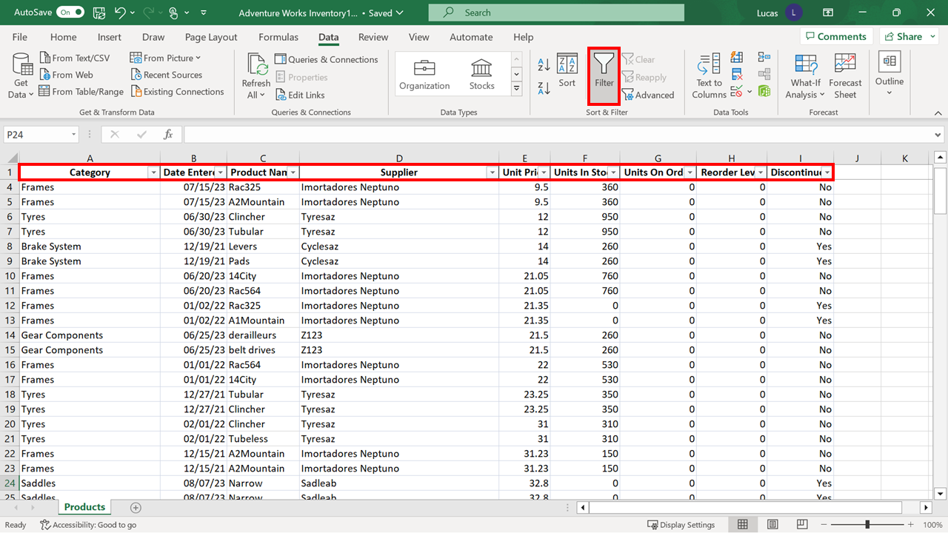

1. You need to identify how many gear components are listed. Select the **drop-down arrow** next to the **Category** heading to open the list of entries. Then select **Select All** choice to remove the tick marks. Select the **box** next to **Gear Components** to replace the tick mark for that entry. When you select **OK**, Excel will only display the rows that contain that entry and will hide all other rows.

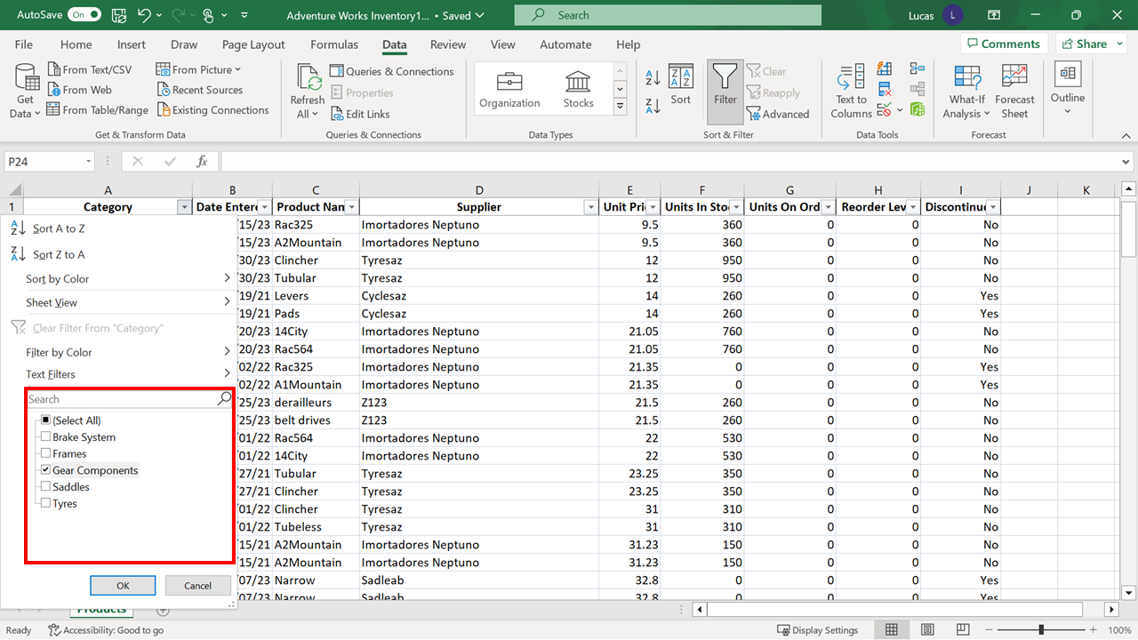

There are gaps in the row numbers on the left of the Excel screen. The **Filter Arrow** next to **Category** has a **funnel symbol** on it. The answer to the query is in the bottom left of the Excel screen.

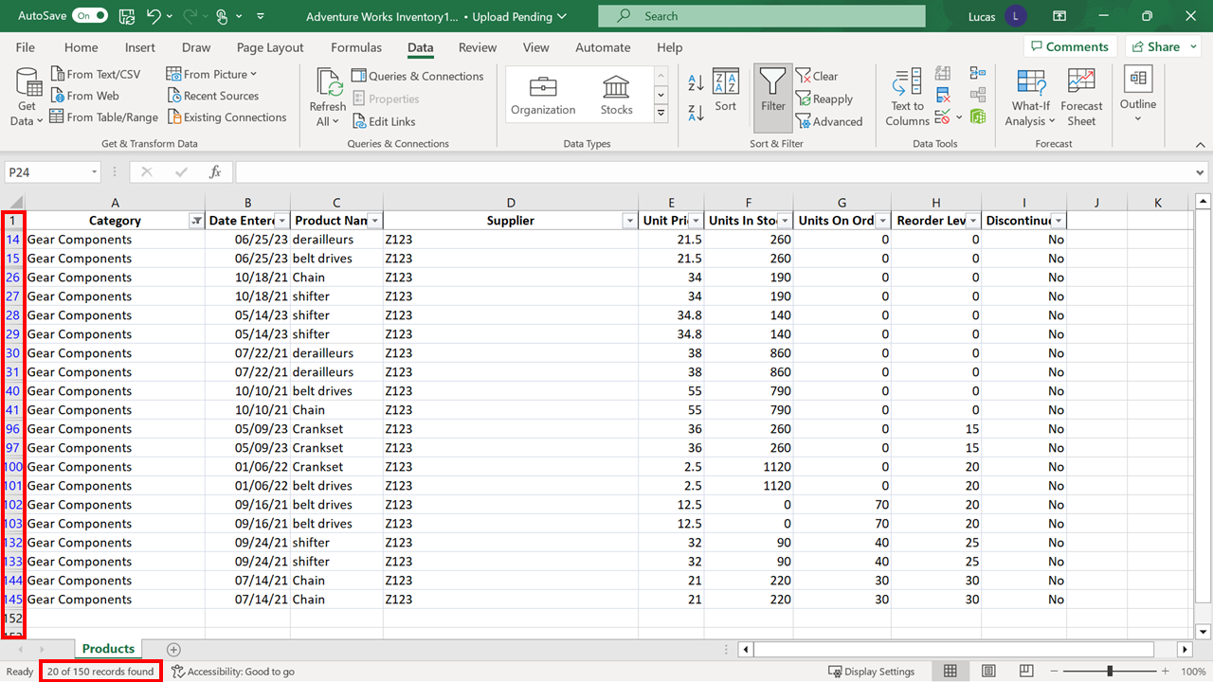

1. Select the **Clear** option on the **Data** tab to remove any filters that are in place on the block of data.

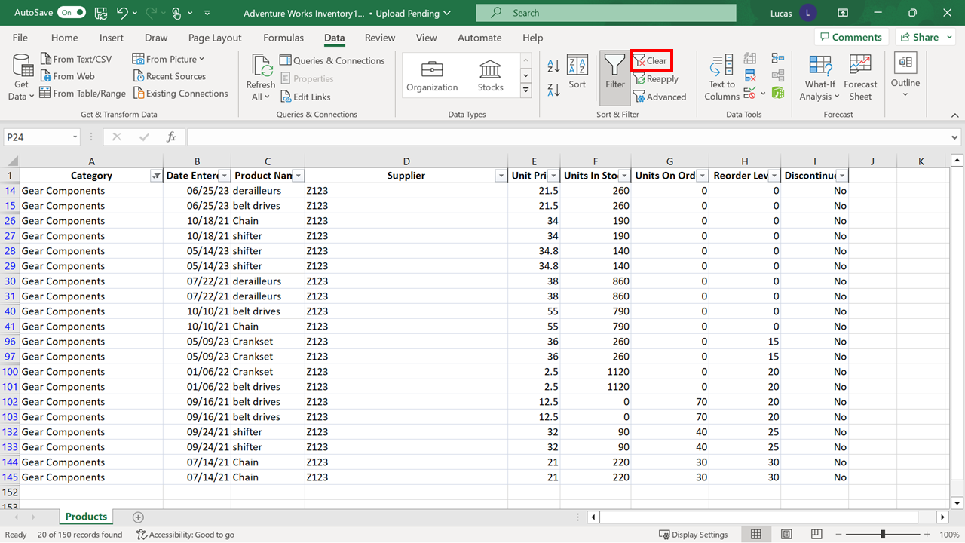

1. Next you need to use the **filter** to determine how many orders were placed with **Z123** in **2023.** First, use the **Filter arrow** next to **Supplier** to refine the display. This will only show records for **Z123**.

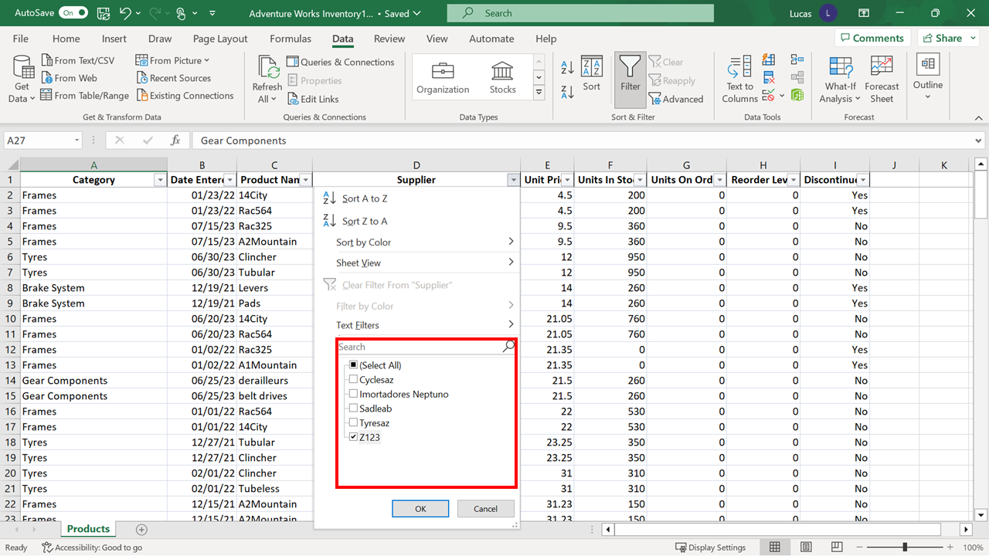

1. When the results are displayed for **Z123**, select the **drop-down arrow** next to **Date Entered**. Then select the correct **year** from the list provided. Select **OK**.

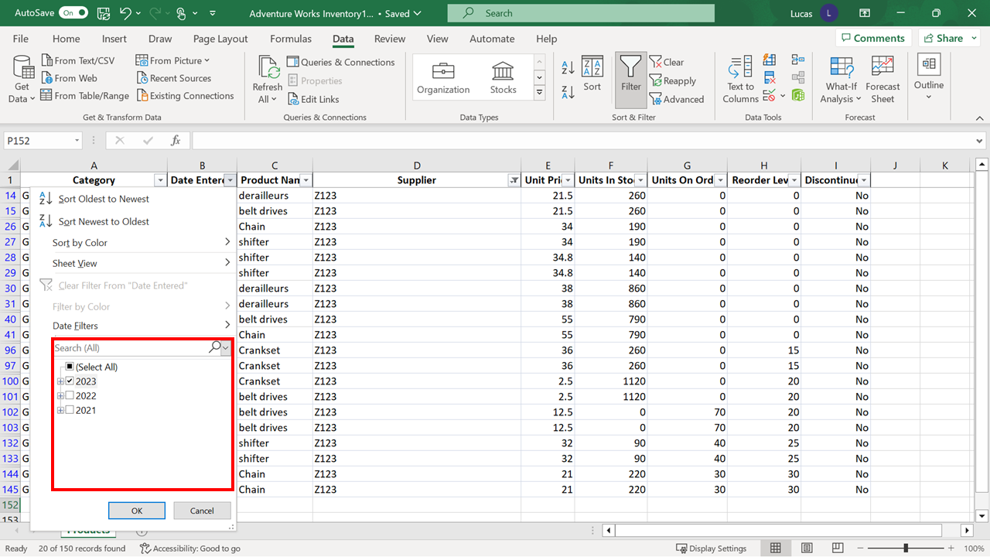

The number of rows reduces to **six**. If you need confirmation, the answer to the query is in the bottom left of the Excel window.

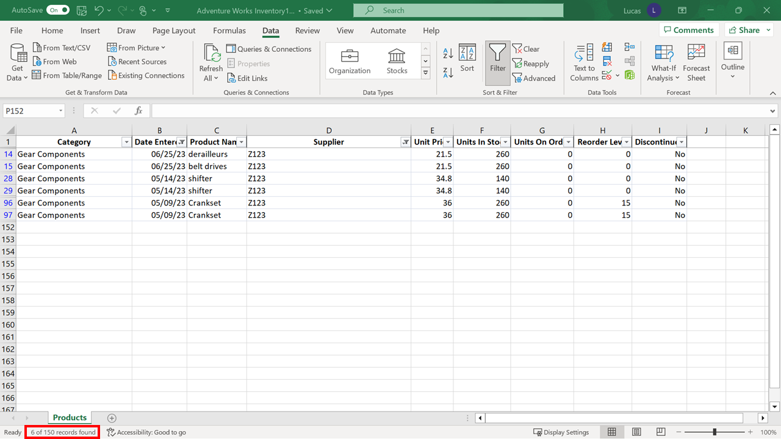

1. The next task is to change the **Filter** to discover how many orders were placed with **Z123** in **2022**. To adjust only the **Date Filter,** select the **arrow** and select the **checkbox** for **2022**. Select **OK**.

Remember, the Filter on **Supplier** is still in place. The answer to this question is **two**.

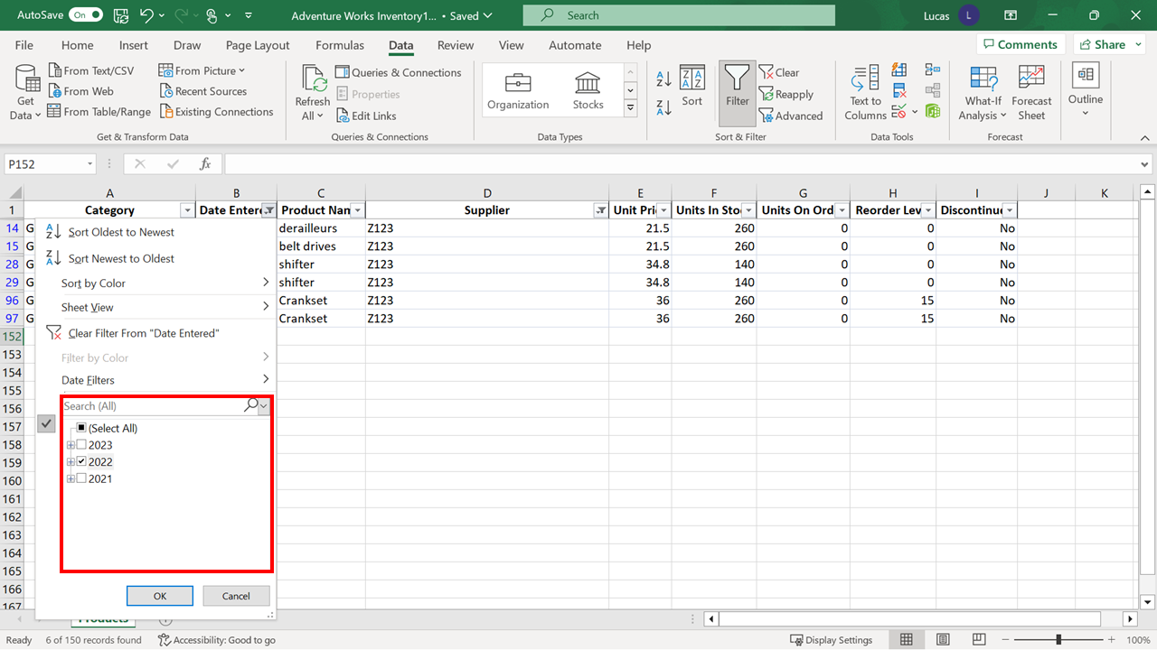

Before you move on to find the answer to the next question, you need to reset the data so that all rows are displayed. You can do this by removing all the filters already in place. On the **Data** tab, select the **Clear** option.

1. You need to use the filter to determine how many records in the data are for mountain bike frames. You must filter the data by **Product Name** to discover the answer to this question. However, when you select the **Filter Arrow** and examine the entries listed, you realize that there is not just one type of mountain bike frame listed. In large data blocks, it would be a slow and inefficient process to have to manually scan the list and tick any entry that referred to mountain bikes. It is possible to filter by a “partial match” since the word “mountain” is used in all the descriptions.

On the **Filter** drop-down, there is another choice called **Text Filters**. When you rest the mouse pointer on this choice, a **sub-menu** opens, and one of the choices is **Contains**. Select this choice.

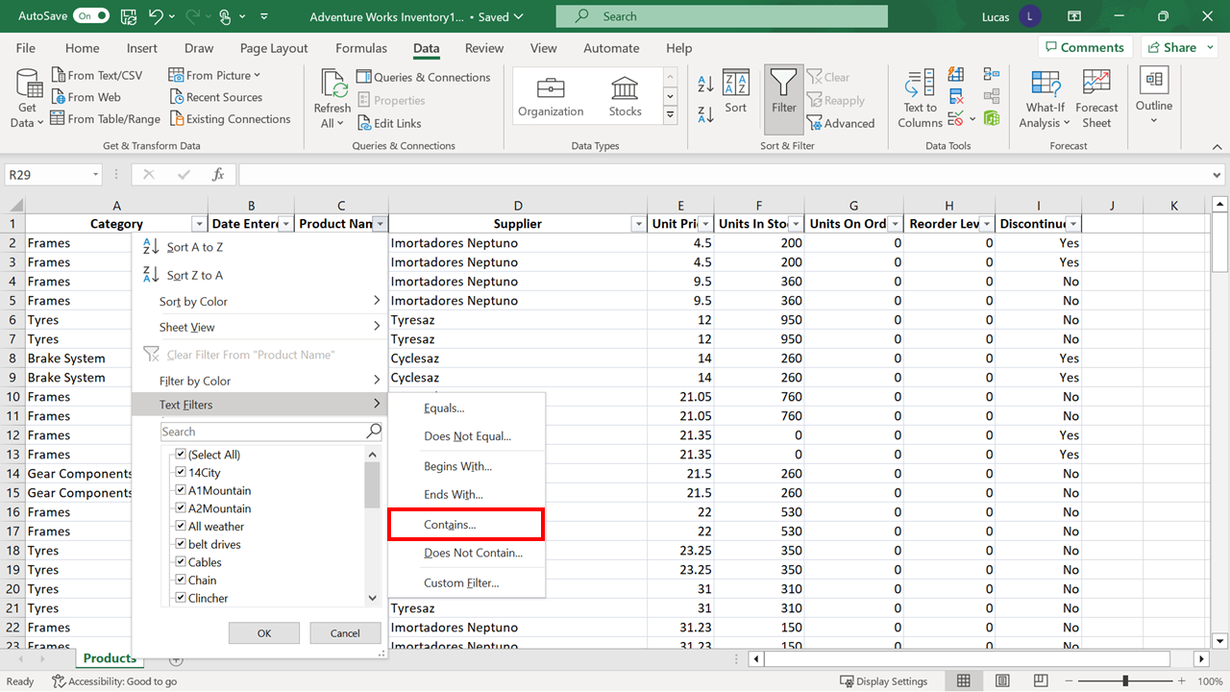

In the **Custom Autofilter** dialog box, you must type the word mountain and select **OK**. This dialog is not case-sensitive.

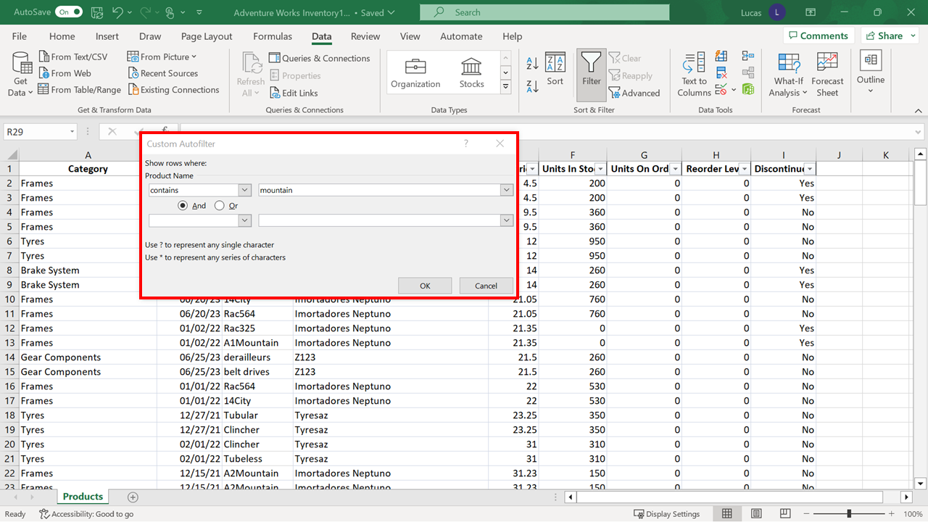

**Twenty-two** rows in the data contain the word "mountain" in the product name.

1. You now need to filter the block of records further to identify how many of the mountain bike orders have a stock level of over 500. Select the **filter arrow** beside the **Units in Stock** heading. Because Excel is aware that this column contains numeric data, the choice on this menu is called **Number Filters**, and when the mouse pointer rests on this choice, the sub-menu contains appropriate choices.

When you select the **greater than** option, the **Custom Autofilter** dialog box opens.

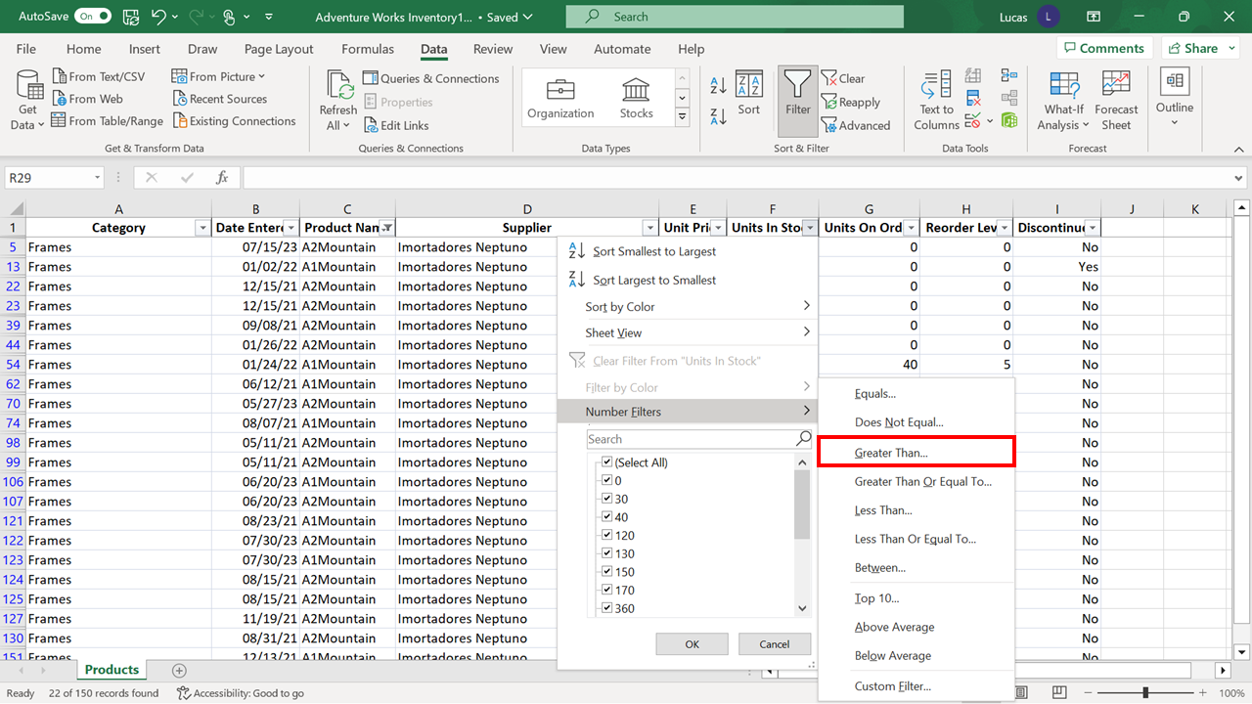

When you type 500 and select **OK**, the result is **three** rows.

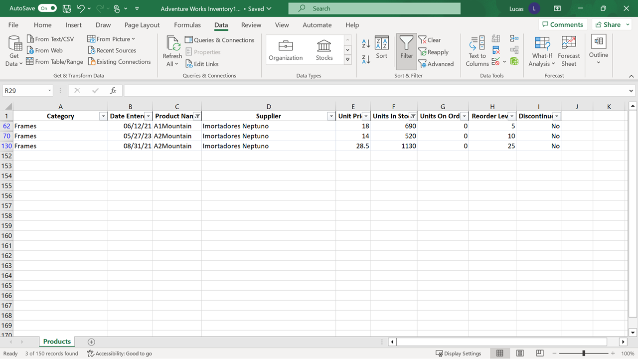

**Conclusion**

Congratulations! You have successfully completed this exercise. You now know how to **Sort** data in a worksheet when a different order is required and how to use the **Filter** feature to ask questions about the data and discover answers. Asking questions about data and discovering the answers is one of the key concepts in data analysis.